Technical Architecture Document: VeriHarvest

## **1. Introduction**

VeriHarvest is a **blockchain-powered food authentication system** that integrates **AI, IoT, and decentralized ledgers** to provide real-time food safety monitoring and fraud prevention. This document outlines the technical design, architecture, and implementation strategy.

## **2. System Overview**

VeriHarvest consists of:

1. **AI Module**: Food fingerprinting via hyperspectral imaging.
2. **IoT Module**: Real-time monitoring via sensors (temperature, humidity, gas levels).
3. **Blockchain Module**: Smart contracts for food traceability and compliance automation.
4. **User Interfaces**: Consumer mobile app, supplier & logistics dashboard, regulatory dashboard.

## **3. System Architecture**

### **3.1 High-Level Architecture**

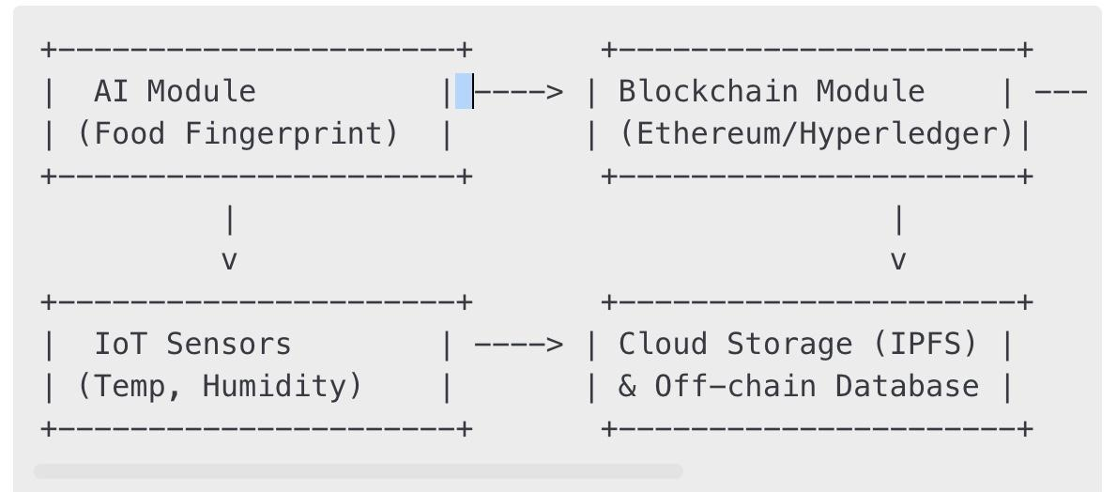

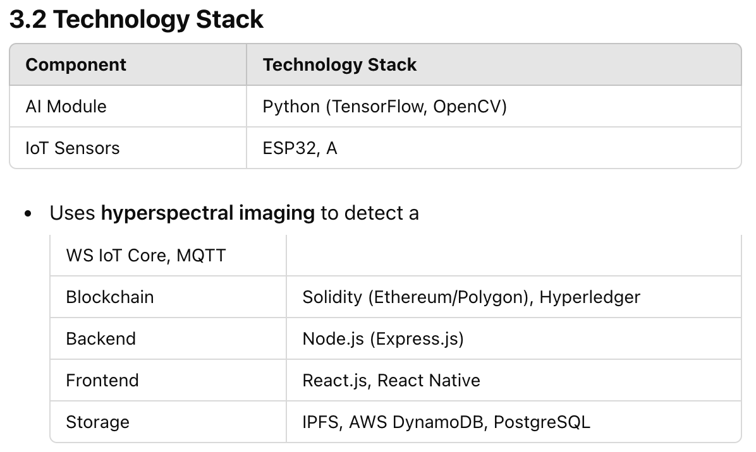

* **4. Key Modules & Workflows  
  4.1 AI-Based Food Fingerprintingdulteration.**
* **AI hashes fingerprints** and stores them **on-chain**.

### **4.2 IoT-Powered Real-Time Monitoring**

* **Embedded sensors** in packaging collect data.
* IoT **pushes data to AWS IoT Core** and **stores critical alerts on-chain**.

### **4.3 Blockchain-Based Traceability**

* **Smart Contracts** manage:
  + **Food Authentication** (Stores AI fingerprints).
  + **Trust Scoring** (Scores batches dynamically).
  + **Compliance Alerts** (Triggers actions when food safety is breached).
* **Data Storage**:
  + **On-chain**: Food fingerprint hashes, compliance logs.
  + **Off-chain**: IoT data stored in **IPFS/AWS DynamoDB**.

### **4.4 User Interfaces**

* **Consumer App**: Scan QR/NFC to verify food authenticity.
* **Regulatory Dashboard**: Monitor flagged food batches.
* **Supplier & Logistics Dashboard**: Track shipments and compliance.

## **5. Security Considerations**

* **Blockchain Encryption**: Ensures immutable records.
* **IoT Security**: Prevents unauthorized sensor data modification.
* **Smart Contract Audits**: Periodic security reviews to prevent vulnerabilities.

## **6. Deployment Strategy**

* **MVP (0-3 months):**
  + Deploy on **Polygon Mumbai Testnet / Hyperledger Fabric**.
  + Pilot **AI fingerprinting with select food suppliers**.
* **Scaling (3-6 months):**
  + Expand blockchain storage to **Layer 2 scaling (Polygon/Arbitrum)**.
  + Integrate with **major food retailers & logistics firms**.

## **7. Conclusion**

The VeriHarvest technical architecture ensures a **secure, scalable, and real-time** food authentication system. By combining **AI, IoT, and Blockchain**, it revolutionizes **food safety, compliance, and consumer trust**.